Experiment-6
Name: S Lakshan Rollno:240701281

Simulate the lifecycle stages for UI design using the RAD model
and develop a small interactive interface using Axure RP

1. Welcome Screen
- This is the initial screen of the application
- It provides options like Sign up and Log in
- These buttons are used for navigation in the prototype
- The design is simple and visually clean
- It gives users a basic idea of how the app starts

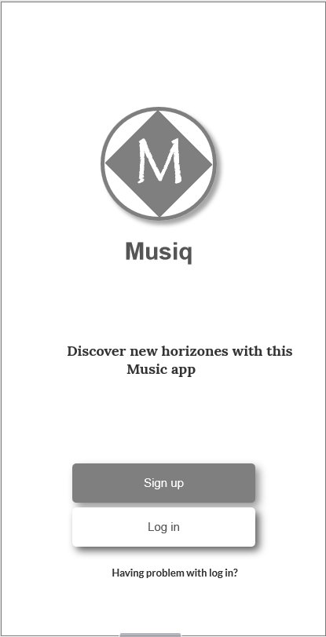

2. Sign Up Screen
- This screen is designed to show how user registration will look
- It contains input fields like username, email, and password
- Social sign-up options are included for design purpose
- No real data is stored, it is only for UI demonstration using Axure RP
- It helps visualize the registration process

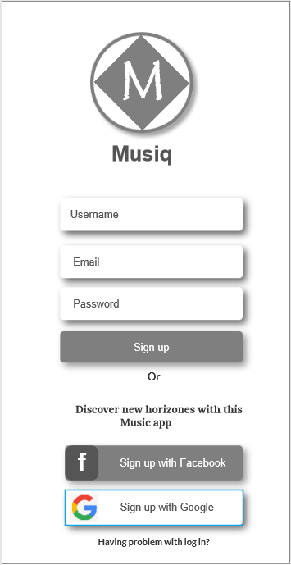

3. Music Player Screen
- This screen represents the music player interface design
- It displays song details like title and artist
- Includes controls such as play, pause, next, and previous
- Buttons are used to simulate interaction in the prototype
- It gives an idea of how the final music app will function
